NAME: Yaw Goh Asare
SM/SMS/08/0014 17/10/2008

EXPERIMENT 10

TITLE: THE ACCELERATION DUE TO GRAVITY BY MEANS OF A
SPIRAL SPRING

AIM: To determine the acceleration due to gravity by means of a spiral spring

APPARATUS: spiral spring, slotted weights, half-metre rule, stop watch.

DIAGRAM
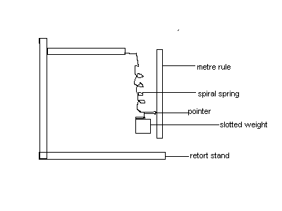

THEORY
The acceleration due to gravity is defined as the constant acceleration of a free falling body .The acceleration due to gravity is always directed towards the centre of the earth hence has a negative value no matter a body’s position above the surface of the earth. The acceleration due to gravity is totally independent of the mass but rather the distance from centre of the earth.
Hooke’s Law forms the basis of this experiment. Hooke’s Law states that the extension produced in a material is proportional to the applied load provided the elastic limit is not exceeded. From the diagram below, consider a spiral spring PA suspended from a fixed point P, when a mass M is placed on it, the spring stretches to O by a length e(extension) given by:
Mg = µe …..(1)

where µ is the force constant (force per unit extension) of the spring. The tension in the spring is equal to mg. At B, the tension T of the spring is equal to µ(e+ x) =Mg. Making M the subject of the equation:

M=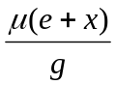

Comparing this equation to the equation of a straight line y=mx it is seen that a graph of load (mass) against pointer readings, the slope will be, where µ is the force constant. Mathematically,

Slope 1=µ/g.....(1)
.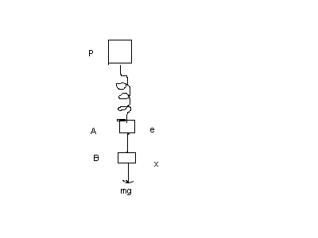

The equation for the periodic time is T=2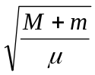..(2). Where M is the mass of the slotted weight and m is the mass of the weight of the spring and m is the spring mass.
Since T=t/50, 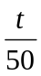=2 and M=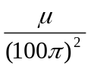t² (3)
The slope of the graph of load against time t² is equal to μ/(100)²×t² from equation (3). This gives us μ. Substitute in (1) above for the acceleration due to gravity(g).
METHOD:
The spring is suspended so that it hangs vertically from a rigid support and to the lower end slotted weights are attached. A pointer is attached to the spring to record the reading of the weights. The reading of the pointer and the attached weight is recorded. The load is increased by successive increments of 10 or 20g and the pointer is recorded each time. The weights were unloaded when about 6 such readings have been taken and the pointer readings recorded each time. The results are tabulated. A graph of the values of the load on the y-axis and the mean pointer readings on the x-axis is plotted. Now using the spring the time for 50 oscillations as the load is increased. The results is tabulated. A graph of load against t² is plotted.

RESULTS
Initial pointer reading=30.0 0.1cm
Least count of metre rule=0.1cm
Load(g) | Load increaSing(cm) | load decreasing(cm) | mean pointer reading(m)
20.0 | 0.4 | 0.3 | 0.0035
40.0 | 5.0 | 5.1 | 0.0505
60.0 | 10.6 | 10.7 | 0.1065
80.0 | 16.3 | 16.4 | 0.1635
100.0 | 22.4 | 22.1 | 0.2225

Table 2
Least count of stop watch=0.01s
load(g) | time for 50 oscillations |  | mean t (s) | t² (s²⁾
 | t₁ (s) | t₂ (s)
20.0 | 28.22 | 28.85 | 28.535 | 814.2462
40.0 | 49.34 | 50.28 | 49.810 | 2481.036
60.0 | 55.94 | 56.09 | 56.015 | 3137.680
80.0 | 60.50 | 60.44 | 60.470 | 3656.621
100.0 | 65.03 | 65.40 | 65.215 | 4252.996

GRAPH
A graph of load (g) against extension(m).
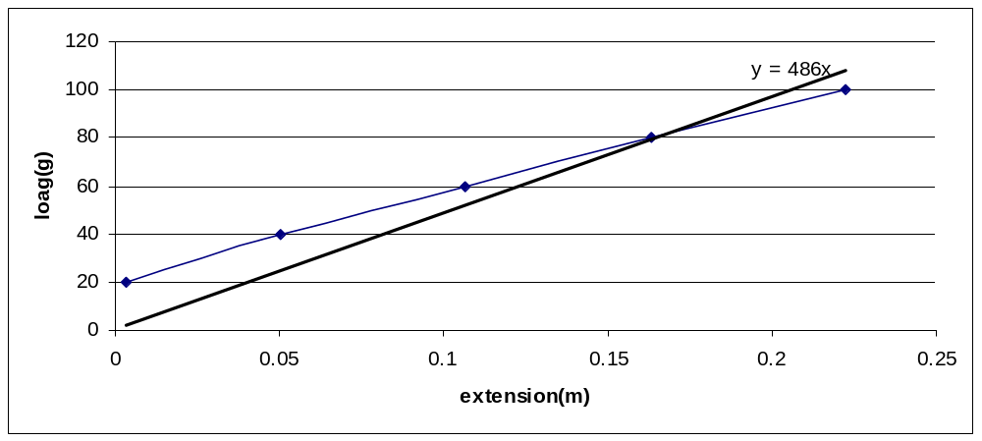

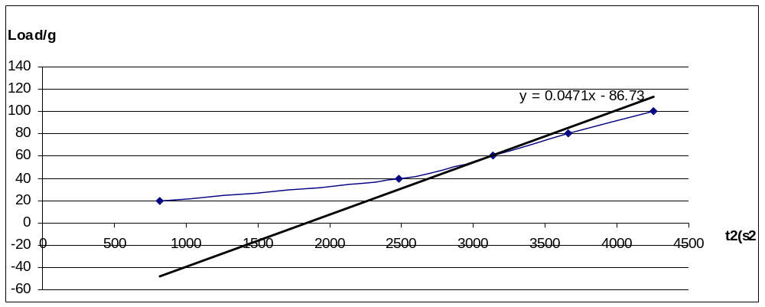
A graph of load (g) against t²(s²)

CALCULATION
The slope of the graph of load (g) against t² is 0.0471 g/s² =
=0.0471×(100)π²
=4648.58 g /s²
The slope of the graph of load (g) against extension (m) is 486g/m = µ/g(acceleration due to gravity).
g = µ×slope
g = 4648.58 g/s² ÷ 486g/m
Acceleration due to gravity (g) = 9.565m/s²

DISCUSSION

Acceleration due to gravity on the earth varies from place to place according to position on the earth and air resistance. In this experiment the force constant of the spring was gotten from the load against time graph and used to find the acceleration due to gravity. The calculated value was 9.57m/s² which deviated from the actual value of 9.8m/s² by about just 0.235m/s². Some errors accounted for this deviation. The oscillation were not clearly differentiated so one oscillation was difficult to be counted from another hence the timing may have had some errors therefore affecting the value of µ. Also the masses seem to have been corroded so the actual weight of the masses may be different from the valued masses and therefore both slopes may have been affected. The elastic ability of the spring was quite close to the elastic limit hence the spring gave very long extensions for equivalently small weights which may have affected the slope of the graph of load against extension hence affected the g. The pointer giving could not fit properly and so could not measure the value of the extension well this caused a deviation in the slope. Air resistance also caused some deviations in the extension. Corrosion in the spring also caused some errors in the value of the calculated acceleration due to gravity

CONCLUSION
The acceleration due to gravity could be determined by means of a helical spring.

ERRORS:
- Error in timing due to difficulty in counting the oscillations.
- Damping set in due air resistance.
- The pointer given could not fit properly causing some errors in the extension measurement.
- Corrosion in the slotted weights and spring caused some errors

PRECAUTIONS
- It was ensured that the spring was oscillated through a slight displacement
- It was ensured that the fans were switched off to reduce air resistance that would have affected the oscillation of the spring
- It was ensured that the timing was made immediately after the first oscillation.
- It was ensured that pointer was held firmly in the spring for accurate readings.

REFRENCES

- RAYMOND A. SERWAY, JERRY S. FAUGHN (COLLEGE PHYSICS), 6TH EDITION 2003.

2. YOUNG FREEDMAN (UNIVERSITY PHYSICS) 9TH EDITION, PAGES 405-404.PUBLISHED BY ADDISON-WESLEY PUBLISHING COMPANY

